**Comparing Income by Various Transportation Types in NYC and DC** 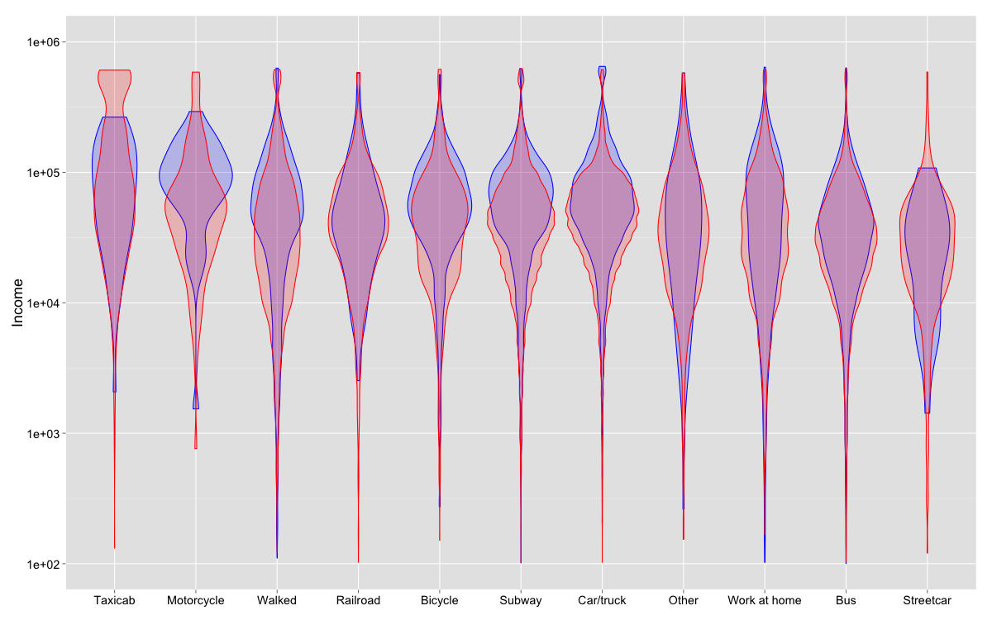

The main finding in the comparison of Washington D.C. with New York City is that generally, more affluent people ride motorcycles and taxis, while the least affluent ride buses and streetcars. This was true for both metropolitan areas. When looking at taxicabs alone, it was striking how much more affluent NYC cab riders were vs. DC riders (estimated median income of $162,623 vs $90,779). Car drivers tended to be more affluent in DC ($81,761 vs. $54,812) and also make up the greatest proportion of people using this transport type. New Yorkers proportionately used the subway the most.

|  |  |  |  |  |  |  |
| --- | --- | --- | --- | --- | --- | --- |
| **NYC vs DC** | | | | | | |
|  |  | |  |  |  |  |
|  | **est. Median Income** | | |  | **Proportion of Total** | |
| **Taxicab** | $162,623.39 | $90,779.13 | |  | 0.010 | 0.003 |
| **Motorcycle** | $82,623.96 | $99,128.61 | |  | 0.001 | 0.002 |
| **Walked** | $58,079.78 | $68,775.86 | |  | 0.098 | 0.122 |
| **Railroad** | $57,451.32 | $64,264.63 | |  | 0.021 | 0.005 |
| **Bicycle** | $57,254.29 | $70,268.39 | |  | 0.008 | 0.034 |
| **Subway** | $56,197.24 | $69,154.27 | |  | 0.403 | 0.218 |
| **Car/truck** | $54,812.17 | $81,761.72 | |  | 0.304 | 0.420 |
| **Other** | $52,826.28 | $59,162.29 | |  | 0.006 | 0.006 |
| **Work at home** | $52,407.33 | $63,153.15 | |  | 0.029 | 0.040 |
| **Bus** | $41,659.40 | $47,189.02 | |  | 0.120 | 0.148 |
| **Streetcar** | $38,597.66 | $32,195.86 | |  | 0.003 | 0.002 |